Chapter 11, E1, due May 7, 0.7 points

Part 1. Answer the text question
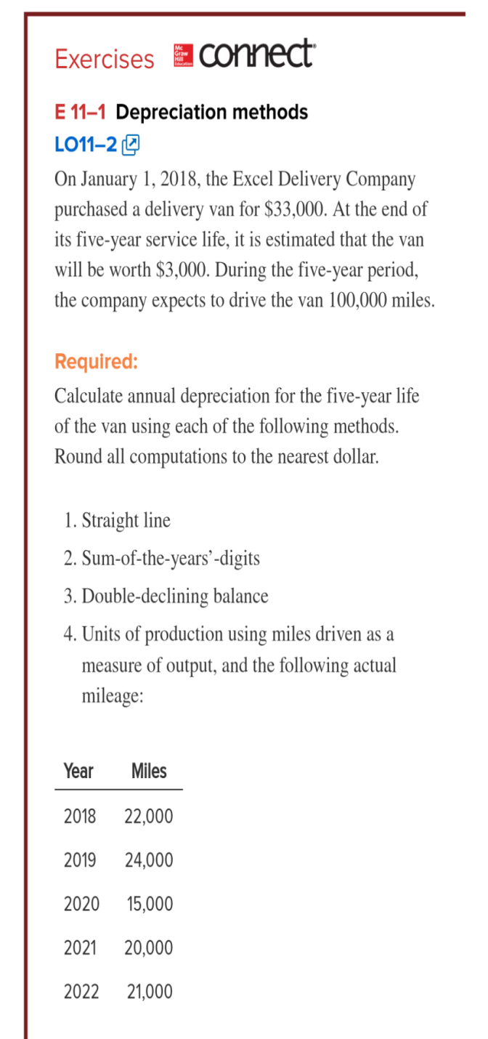 | SL (same each year)  SYD, Years 1-5  DDB, Years 1-5  UoP, Years 1-5  #1. Depreciation = (Cost of the Asset – Residual value) / (Estimated useful life of the asset)  = (33,000-3,000) / 5 years  = 30,000 / 5 years  = $6,000 per year  #2. Sum-of-the-digits=(n x (n+1)) / 2  =(5 x (5+1)) / 2  = (5 x 6) / 2  = 15  Depreciable base = Cost of the Asset – Residual value  =33,000 – 3,000  =30,000  #3. Depreciation rate = (100% / 5years) x 2  = 40%  #4.  Depreciation per mile = (cost-residual value) / estimated units of usefule life  =(33,000-3,000) / 10,000 miles  =$.30 per mile depreciation rate
  Year | Depreciable Base |  | Depreciation rate per year |  | Depreciation
  2018 | 30,000 | X | 5/15 | = | 10,000
  2019 | 30,000 | X | 4/15 | = | 8,000
  2020 | 30,000 | X | 3/15 | = | 6,000
  2021 | 30,000 | X | 2/15 | = | 4000
  2022 | 30,000 | X | 1/15 | = | 2,000
  Total |  |  |  |  | 30,000
  Year | Book Value of Beginning year | x | Depreciation rate per year |  | Depreciation | Book Value of the End of the year
  2018 | 33,000 | X | 40% | = | 13,200 | 19,800
  2019 | 19,800 | X | 40% | = | 7,920 | 11,880
  2020 | 11,880 | X | 40% | = | 4,752 | 7,128
  2021 | 7,128 | X | 40% | = | 2,851 | 4,277
  2022 | 4,277 | X | 40% | = | 1,277 | 3,000
  Total |  |  |  |  | 30,000
  Year | Book Value of Beginning year | Actual miles driven | x | Depreciation rate per year |  | Depreciation | Book Value of the End of the year
  2018 | 33,000 | 22,000 | X | 30% | = | 6,600 | 26,400
  2019 | 26,400 | 24,000 | X | 30% | = | 7,200 | 19,200
  2020 | 19,200 | 15,000 | X | 30% | = | 4,500 | 14,700
  2021 | 14,700 | 20,000 | X | 30% | = | 6,000 | 8,700
  2022 | 8,700 | 21,000 | X | 30% | = | 5,700 | 3,000
  Total |  | 102,000 |  |  |  | 30,000

